# Lab 2: Add a Device to an Azure IoT Hub

In this lab you will register a device on the Azure IoT Hub.

In this lab the following actions will be performed:

* Install Azure IoT Hub Device Explorer
* Create a new Azure IoT Device
* View Device properties in the Azure Portal – Preview
* Cleanup

## What you will need:

* Microsoft Azure Account
* Azure IoT Hub

## Install Azure IoT Hub Device Explorer

Azure IoT Hub only allows connections from known devices that present the proper connection strings. In this section you will use the Device Explorer to provision a new device within the Azure IoT hub.

1. Download and Install the Device Explorer from: <https://github.com/Azure/azure-iot-sdks/releases/download/2016-06-30/SetupDeviceExplorer.msi>
2. Open the device explorer and paste the connection string in the “IoT Connection String” field and click on “Update”

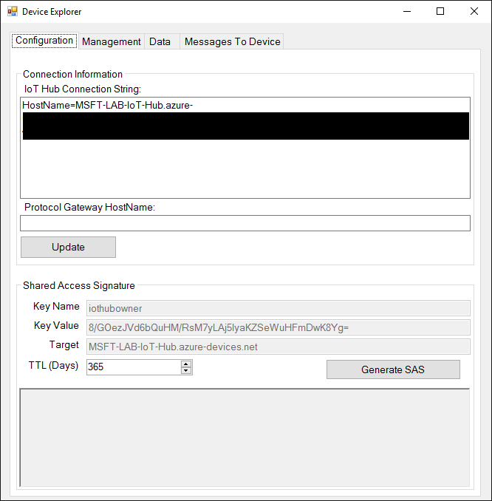

## Create a New Azure IoT Device

1. Open de Device Explorer tool.
2. Open de “Management” tab.
3. Click on “Create”

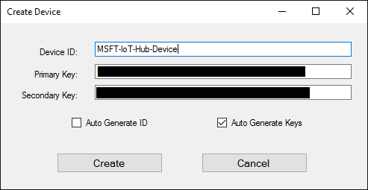

1. Fill in the device ID from the device, save as the preconfigured one and represented in the configuration interface (without ESP) and click “Create”.
2. In the list select your device and click on the SAS Token button.

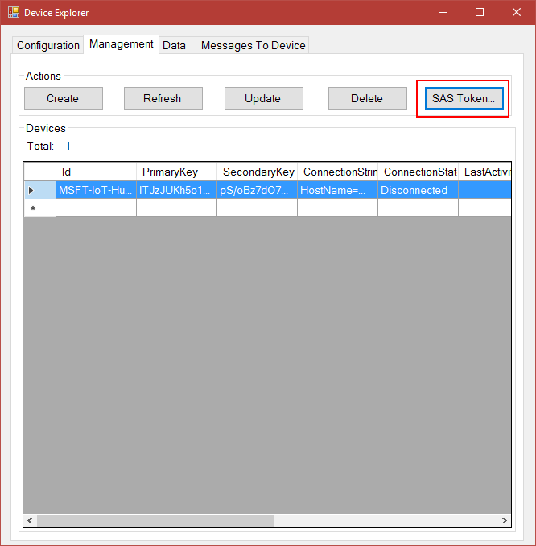

1. Set the TTL to 365 and click on generate.

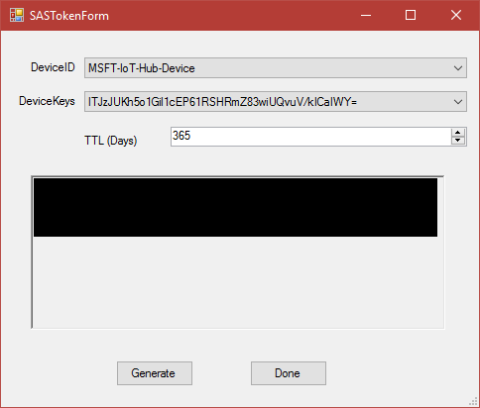

1. Copy the generated SAS Token, we need this further on for the configuration of the device.
2. Open up the webpage of the device (<http://192.168.4.1>)

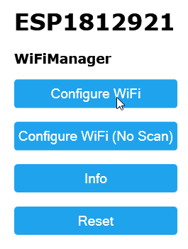

1. Now click “Configure WiFi”.
2. Ask one of the instructors for the SSID and password in your location. You can simply click the required SSID and enter the password.
3. 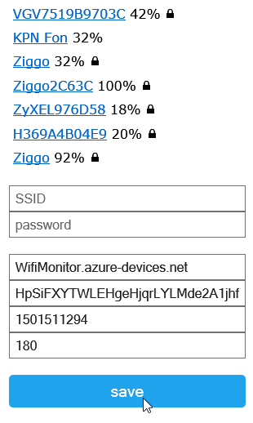Change the other settings from top to bottom.

|  |  |  |
| --- | --- | --- |
| Property | Description | Information |
| HostName | The hostname of the IOT Hub | Copy the hostname out of the SAS Token. |
| Primary Key | The primary key of the device. | Copy the device data by using the right mouse button on the device and get the primary key from there. |
| SAS Expiration | The SAS Expiration time | The se value of the SAS Token. |
| Interval | The interval for sending message in seconds. | Fill in the appropriate value, 180 is 3 minutes. |

1. After you clicked “save” you will see the following screen:

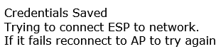

## View Device properties in the Azure Portal – Preview

If you enabled the preview on the IoT Hub the properties of the Device can be viewed in the Azure portal.

1. Click on: Resource groups > Your Resource group > IoT Hub Name
2. In the IoT Hub blade click on the Devices button.

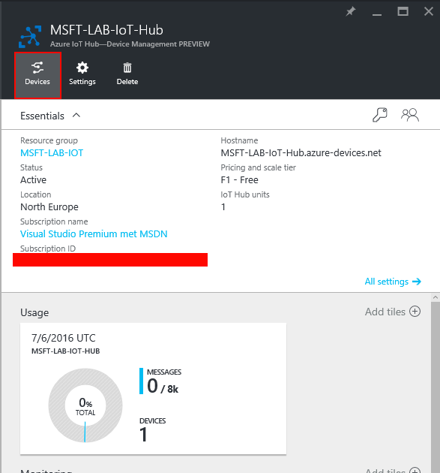

1. This will open the Device Explorer blade. Click on your added blade.
2. In the blade that appears you will see the connection information of your device.

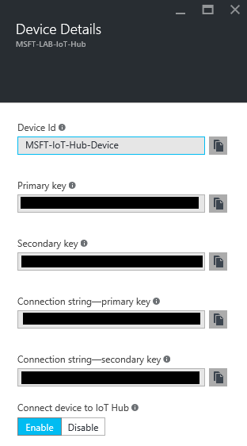

This connection information can be used to connect your created IoT device to the Azure IoT Hub.

## Cleanup.

The following actions will delete all resources created within this Lab, if you want to keep the resources you can skip this step.

1. Open the Device Explorer.
2. Click on the “Management” tab.
3. Select the device you want to remove.
4. Click on the “Delete” button.
5. In the appearing dialog confirm you want to delete the selected device.

